For this programming project I was creating a MYSQL database that can be accessed using a webpage. The webpage would be using PHP to connect with a Python file that stores all of the queries. I created a home page that the user gets to navigate through the use of buttons for each function. I decided to use Python as I used it for the last project and I could reuse the code written for running queries in MYSQL. PHP was used to format the webpages. The database design I used was the one given as an example for this assignment. I had a Team, Game, and Result table created. The Team table used a TeamID, Name, and Nickname. I let the TeamID auto increment as the ID is only used to differentiate in the database side, while the user would want the name to be shown more often than the ID. For the Game table I had a GameID, Location, and Date. The Result table had a GameID for which game was being inserted, the teams IDs and scores. I didn’t implement an error catching, rather I let the errors show up on the screen to then read. Most errors are fairly simple to read, such as the duplicate ID values. I did all of the hosting for this program on Turing. Attached below are some screen shots of the webpages I made.

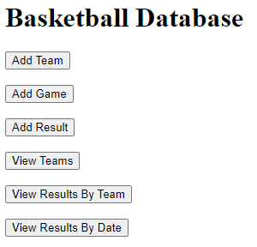

**Home Page**

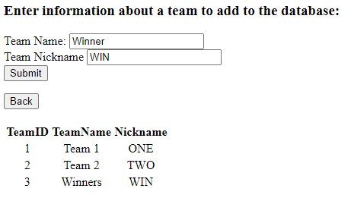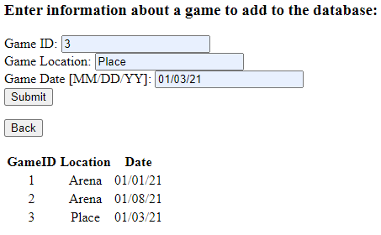

**Add Team Add Game**

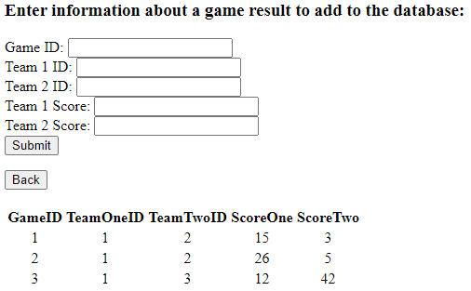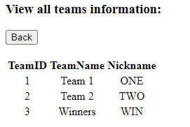

**Add Result View Teams**

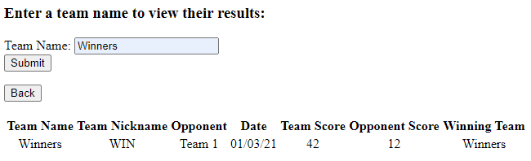

View Results by Team

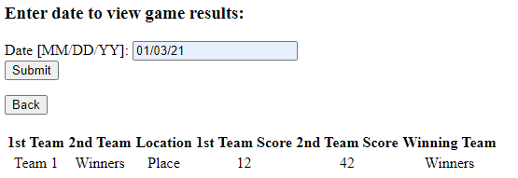

**View Results by Date**